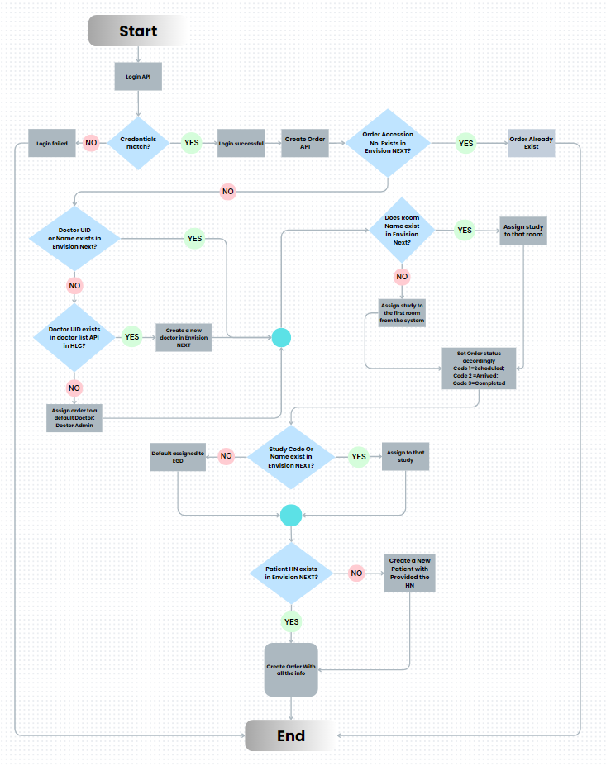

The provided flowchart depicts a comprehensive process for managing orders and studies within the Envision NEXT system. Here's a detailed description of the workflow:
- Start
  - The process begins with a login through the Login API.
- Login Validation
  - Credentials match?
    - No: The login fails.
    - Yes: The login is successful, and the Create Order API is triggered.
- Order Existence Check
  - Order Accession No. exists in Envision NEXT?
    - Yes: The order already exists and is assigned accordingly.
    - No: Proceed to the next validation steps.
- Room Validation
  - Does Room Name exist in Envision NEXT?
    - Yes: Assign the study to that room and set the order status accordingly (Scheduled, Arrived, Completed).
    - No: Assign the study to the first available room from the system.
- Doctor Validation
  - Doctor UID or Name exists in Envision NEXT?
    - No:
      - Doctor UID exists in doctor list API in HLC?
        - No: Assign order to a default doctor (Doctor Admin).
        - Yes: Create a new doctor in Envision NEXT.
- Study Validation
  - Study Code or Name exists in Envision NEXT?
    - Yes: Assign to that study.
    - No: Assign to a default study (EDB).
- Patient Validation
  - Patient HN exists in Envision NEXT?
    - Yes: Proceed to create an order with all the information.
    - No: Create a new patient with the provided HN and then proceed to create an order with all the information.
- End
  - The process concludes with the successful creation of the order containing all necessary details.
This workflow ensures that all necessary validations are performed, and appropriate actions are taken to manage orders and studies within the Envision NEXT system efficiently.

